The Garden Fresh Box Web Application
Front-end and Back-end engineer: Max Gardiner

Table of Contents
The Project Goals 2
Pages Included 2
User Tools: 2
Host Site Tools (Only available to host site coordinators and GFB admins) 2
Admin Tools (Only available to GFB admins) 2
About the Project/Pyramid 4
How to add a new page 5
How to start the server in development mode (no production mode yet) 5
Database schema 6
How the database is associated 6
How the editing timer works (cannot change after 1st Friday of month) 7
Still To Do 8
Notes 9

The Project Goals
The purpose of this project is to provide the GCHC clients with a working website suited to carry out any administrative task relating to Garden Fresh Box. Currently the only system available is to call in via phone to order, and customers must pay with cash when they arrive to pick up a pre-ordered box. By sometime in 2015 the plan is to have a website that will allow customers to order Garden Fresh Boxes from their preferred host site, as well as use PayPal to pay for their box online before they ever go to pick it up. The website will also allow for other users to donate cash via PayPal, and the database will store/offer automatically generated tax receipts over the federal minimum for charitable donations. Moreover, host sites will be able to use the website to review all donations and box orders for their specific site, for each specific pickup date, and they will be able to make changes/transfers therein. A master administrator (to be eventually controlled by a GCHC employee) will exist who will have access to all data from the project, including read/write access to host site and customer order information. The end goal of this project will be a preliminarily tested and working web application suited for properly organizing, administering, and maintaining the Garden Fresh Box project inside-and-out by 2015.

Pages Included
- Home – Home page with links
- Information – Contains information on program, boxes, host sites, and pickup dates
- Purchasing – A page for a user to place a box purchase using online order form
- Donations – Currently linking to CanadaGives.org will eventually integrate with their API once it is updated
- Contact – This page contains contact info for the Guelph Community Health Centre

User Tools:
  - User orders – Lists only orders made by user who is logged in
  - User donations – Lists only donations made by user who is logged in
  - Change user password – User who is logged in may change their password
  - Edit user information – User who is logged in may change profile information

Host Site Tools (Only available to host site coordinators and GFB admins)
  - Manage orders for a particular host site – Edit/add orders associated with a particular host site
  - Edit details (contact info) for particular host site – Edit info associated with host site such as hours of operation

Admin Tools (Only available to GFB admins)
  - Manage user accounts – Manage accounts of users who have signed up; may also be used to assign administrator or host site priveledges
  - Manage complete order list (all host sites) – See orders by host site, if a host site is selected it will open up a page listing all orders for that host site
  - View complete donation list – Lists all donations by users and non-users
  - View complete customer list – List all customers who have purchased boxes, if a user is selected then list his/her orders. Existing orders can be edited as well.
  - Manage the pickup dates for boxes – Manage the pickup dates that are used with forms throughout the site, as well as listed on the info page
  - Manage sample boxes that appear on info page – Manage the example boxes that are listed on the info page

*NOTE: See config/routing.py to get a list of all of the files created for the project (some are under construction or unused); list also contains a description for each page of the website

About the Project/Pyramid
This project is built using Model-View-Controller principles, this is based largely on the fact that Pylons Pyramid Python framework uses this framework as well. For more info on Pylons Pyramid and MVC principles please visit their site at: http://docs.pylonsproject.org/en/latehest/docs/pyramid.html .

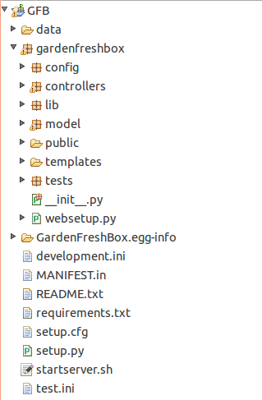
The project itself is based on one of the basic Pyramid scaffolds, and has the following basic structure:
GFB is the main project folder
the data and GardenFreshBox.egg-info are automatically generated and do not need to be changed by anyone
Inside the gardenfreshbox folder is where all of the project code resides:
config contains a number of Python configuration files (including routing table and some Pyramid setup)
controllers contains the Python MVC controllers for errors, hostsites, the index page, purchases, and users
lib contains globals and helper functions
model contains all of the models for the site cookie, user views, hostsite views, sale views, and all access to backend
public contains all data downloaded by user (css, images, js, etc.)
templates contains the web markup in the form of MAKO templates which are basically HTML with some added tricks

- the .ini files (like development.ini) are used by Pyramid to configure the server before launch
- README.txt contains quick info on how to run the development server
- requirements.txt contains a list of applications installed on the production machine
- setup.cfg contains more Pyramid configuration
- setup.py is the Python/Paster setup wrapper that must get run on each development machine before the server can start (startserver.sh is a quick run of dev server)

How to add a new page
- Create the html/mako page(s) for the new page
- Add physical links to the existing mako templates which must link to the new page (in most cases adding it to the sidebar.mako)
- Add the routing information to routing.py in the config folder
- Sometimes new models must be created if adding new functionality

How to start the server in development mode (no production mode yet)
- Setup the python development server: $python setup.py [develop]
- Start the server with the WSGI (in this case its Pserver until Gunicorn or more appropriate gateway is setup): $paster serve --reload development.ini
How to switch over to production machine (ideally)
- Tar the project, and untar on the production machine
- Change the links to the php files located in models/GFBDatabaseController.py for the login verification to the appropriate full links on the production machine (a quick search for “php” in the document will find them for you)
- Install all needed, Apache, Pyramid, PHP, etc.
- Run the project according to README.txt

Database schema
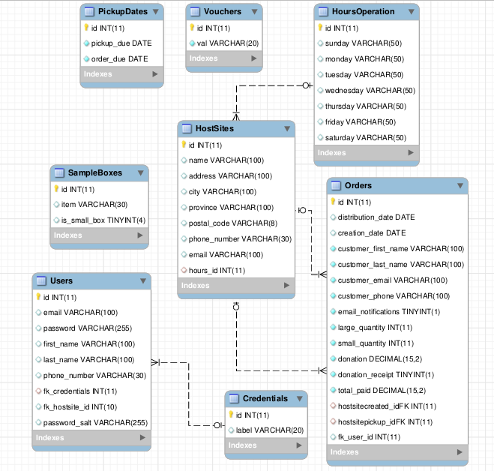

How the database is associated
Within the model folder there is a csv file with access information to the database. If the database is ever moved or changes IP then this is the file that must be changed to update the server. Unfortunately we had to remove database constraints so that the mobile developer and I could continue working with the same database during development, and the proper constraints have never been put back in place.

How the editing timer works (cannot change after 1st Friday of month)
As it stands right now users nor admins can change records after payment has been received, and users cannot change their orders after the first friday of the month.
The same thing goes for not listing past pickup dates in dropdown boxes, in the future perhaps admin should be given opportunity to set past dates.
In the sale.py model the calculation is done in the method called toDistList

Still To Do
- Some sort of back-end sorting must be done to take care of archived orders once this system is used more, for example orders from 2012 and 2013 will not be displayed as readily as orders from 2015, etc.
- Integrate GCHC paypal info with Paypal button on orders
- Integrate GCHC CanadaGives info with donations page
- The Voucher System
- Must have a way of notifying pay in person customers or customers who missed deadlines
- Error messages for orders that cannot be edited anymore due to time passed or payment received
- A forgot-your-password page will be necessary but we will force them to change their password upon entering
- Cross site request forms (XSS) need to be looked over for security issues, someone else with more experience should look at my fixes
- It is recommended that forms be validated in the backend as well
- Email server setup integrate with system
- Setup on production machine
- Purchase domain name (gardenfreshbox.ca) and associate it with production server
- Beta testing

Notes
- The passwords are hashed and salted using PHP's builtin abilities to do so
- Shellshock use of python command line security issues fixed
- Inputs to database are sanitized
- Penetration testing necessary still, as I AM NOT A SECURITY EXPERT
- Still waiting on a main logo for the header
- Feedback from users will be nice because I have a feeling more instruction will be necessary for some of the pages especially admins
- As it stands right now validation.js contains all validation javascript for forms, and each html file has it's own js file. I realize this is not properly compartmentalized but I did this for simplicitys sake, as this is my first major web application

